BSCI 440; Exam I Lab section #:_____________________
Spring, 2003; William J. Higgins

Dirctions:

1. Print your name on each page of the examination before you do anything else! Do it now, and do it neatly.
2. You absolutely, positively MUST confine your answers to the spaces provided. Failure to do so may result in an inaccurate evaluation of your knowledge.
3. Complete the exam using a PEN if you wish to retain the right to discussing your answers with Dr. K-I-A.
4. You must include sign and/or units in all answers requiring them.

SCOREBOARD
Question | Higgins Points | Visitor’s  Points | Question | Higgins Points | Visitor’s Points
1 | 10 |  | 6 | 19
2 | 18 |  | 7 | 18
3 | 15 |  | 8 | 6
4 | 22 |  | 9 | 6
5 | 36 |  | TOTAL | 150

#1. Why can someone with Type A blood receive a transfusion of Type O blood but not of Type AB blood?

________________________________________________________________________

________________________________________________________________________

________________________________________________________________________

________________________________________________________________________

________________________________________________________________________

________________________________________________________________________

________________________________________________________________________

#2. Examine the axes (and the numbers on the axes!) below and carefully follow the directions given in questions a through e.
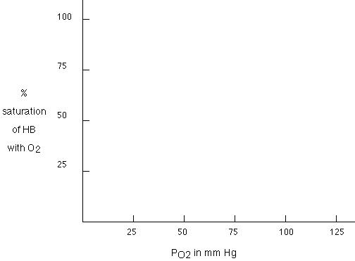

a. Carefully and with complete accuracy, fill in the curve for normal adult hemoglobin. Label it with an A.
b. Based on your curve above, what is the P₅₀ value of Hb? ________________
c. Now plot the curve for fetal Hb. Label it with an F.
d. Myoglobin is a monomeric protein found in skeletal muscle. Myoglobin binds and stores oxygen in the muscle. Draw the curve for myoglobin: Label it M.
e. List two things that would shift the curve for Hb A to the right:

____________________________ and __________________________

#3. a. Agent R increases blood pressure but does not alter
heart rate. Agent R is _________________
b. Agent T does not change heart rate and does not block the response of the intestine or the heart to ACh or NE. It does induce a slight increase
in BP and eliminates the response of the bronchioles to Epi.
Agent T is acting as _________________
c. Agent W does not change heart rate, decreases BP,
and induces intestinal cramps. Agent W is _________________

#4. Dr. Harley Schmedlap, Jr., noted physiologist, 440 alumnus, and part-time UM snow shoveler, has discovered a new form of life burrowing under the snow piles on campus. These furry little creatures feed on the blood of frustrated 440 students who fling themselves into the snow in frustration over not understanding pharmacology. Schmedlap has named this creature Horrillibus higginsus and now requests your help in completing the analysis of the following data:

[Ion]_{intracellular} [Ion]_{Extracellular} Relative Permeability

Na⁺ 12 mM 141 mM 0.05
K⁺ 125 mM 6 mM 1.0
Cl⁻ 11mM 135 mM 0.1
Ca⁺⁺ 10 μM 10 mM 0.0

a. The actual, accurate value of the membrane potential is __________________

b. The equilibrium potential of Ca⁺⁺ is __________________

c. Increasing the conductance of which two ions will induce hyperpolarization?

______________ and ________________
d. Increasing the extracellular concentration of which ion will induce depolarization?

______________ and ________________
e. If V_{m} were equal to - 111 mV, would Cl⁻ enter or leave the cell? ____________

f. The maximum height of an action potential on a nerve in this creature would be:

__________________
g. In fewer than 5 words: what is responsible for the refractory period of a nerve?

____________________________________________________________

Now Schmedlap recorded an action potential from the nerve cells of this creature and provides the data below. Use this graph to answer questions h through ?.
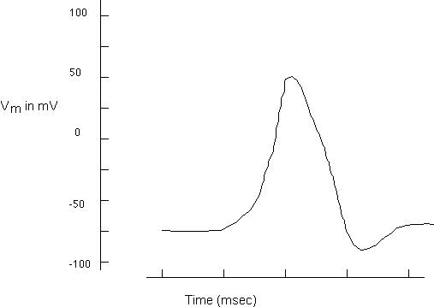

For h through l below: According to the graph above,

h. what is the value of V_{m}? h_________________

i. According to this plot, what is the E of Na⁺ ? i_________________

j. According to this plot, what is the E of K⁺ ? j_________________

k. How long do the voltage-gated Na⁺ channels remain open k________________

l. How long do the voltage-gated K⁺ channels remain open? l________________

#5. Predict the action of each of the following agents on each of the following QUANTITIES by using I, D, or No Δ.
 | ACh | Εpi | propranolol | Nicotine | α1 agonist | α2 agonist | histamine | NE
ACh release from parasymp nerve terminal
Ventricular muscle strength
Heart
Rate
Pupil
diameter
Blood Flow to skeletal muscle
Blood Flow to intestine
Flow of
saliva
Bronchiole diameter
Secretion of stomach acid
#6. Each of the following can be answered in one to three words. Do so:
a. Why has myelin evolved in vertebrates?
_______________________________________________________
b. Where do the parasympathetic nerves exit
the spinal column: __________________ and __________________
c. Increasing the G of Na⁺ on a post-synaptic neuron would
result in what specific event? c________________
d. Serotonin does what to arteries and arterioles?
d________________
e. What protein binds both collagen and platelets?
e________________
f. As the hematocrit increases above normal levels,
plasma EPO f__________
g. As plasma [prostacyclin] increases, the rate of platelet plug
formation would g__________
h. As kidney function declines in a human subject, plasma
total bilirubin levels h___________
i. As liver function decreases in an alcoholic subject, plasma
free bilirubin i___________
j. As blood oxygen levels decrease, the number of circulating
reticulocytes would soon j___________
k. The most numerous phagocytic polymorphonuclear
granulocyte is k___________
l. This circulating granulocyte cell releases both
heparin and histamine l___________
m. This white blood cell is monomorphonuclear and
differentiates into an antibody producing cell m___________
n. As plasma levels of NO increase, platelet aggregation
will n___________
o. Aspirin (acetyl salicylic acid) works as a “blood thinner”
by inhibiting the synthesis of which specific molecule? o_________________
p. As plasma [histamine] increases, the work of breathing
p___________
q. As red blood cell [2,3 DPG] decreases, Hb P₅₀
q___________
r. As hypothermia progresses, O₂ delivery to cells
r___________
#7. Atropine used to be prescribed as a treatment for ulcers. List three prominent side effects of this drug:

1. ___________________________________________

2. ___________________________________________

3. ___________________________________________
#8. Advise an Rh+ mother who learns that she is pregnant with an Rh – child. Is there a problem? Explain briefly.

_______________________________________________________________________

_______________________________________________________________________

_______________________________________________________________________
#9. Clotting Factor X was originally called the Stuart Factor after the unfortunate individual who was missing it. Factor XII was similarly celled the Haegman Factor. Who had the bigger problem, Stuart or Haegman? Explain.

_______________________________________________________________________

_______________________________________________________________________

_______________________________________________________________________

_______________________________________________________________________

