BSCI 440; Exam II Lab section #:_____________________
Spring, 2003; William J. Higgins

Dirctions:

1. Print your name on each page of the examination before you do anything else! Do it now, and do it neatly.
2. You absolutely, positively MUST confine your answers to the spaces provided. Failure to do so may result in an inaccurate evaluation of your knowledge.
3. Complete the exam using a PEN if you wish to retain the right to discussing your answers with Dr. K-I-A.
SCOREBOARD
Question | Higgins Points | Visitor’s  Points | Question | Higgins Points | Visitor’s Points
1 | 49 |  | 6 | 13
2 | 21 |  | 7 | 12
3 | 15 |  | 8 | 5
4 | 15 |  | 9 | 10
5 | 20 |  | 10 | 40
 |  |  | TOTAL | 200

#1. Let’s get right to it! Use I, D, or NoΔ please:

AGENT | HR | SV | TPR | VR | DP | PP | MAP
Epi
α agonist
β agonist
Muscarinic
agonist
β antagonist
α1 antagonist
Angiotensin II

#2. Consider the following ECG. Complete the table below by indicating if the valves are OPEN or CLOSED and the other factors are I, D, or NoΔ at the three indicated points.

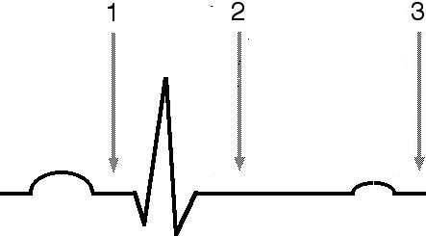

 | At point #1 | At point #2 | At point #3
Mitral Valve
Aortic Valve
Ventricular Volume
Atrial Volume
Aortic BP
Ventricular Pressure
Atrial Pressure

#3. For each of the phases of the ventricular muscle action potential, please indicate whether the conductances of Ca⁺⁺ , Na⁺ , and K⁺ are I, D or are not involved, not different from resting Vm levels or changing during that phase – use NoΔ.

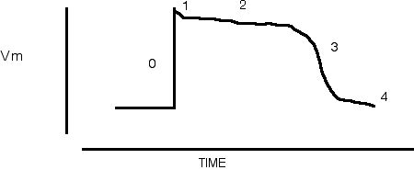

PHASE | G of Ca⁺⁺ | G of Na⁺ | G of K⁺
0
1
2
3
4

#4. Please LIST the steps in the intracellular mechanism that follows β1 receptor activation by NE and results in increased stroke volume. Dr. K-I-A has done the first step for you.
1. NE binds to β1 receptor

#5. Please LIST the steps in the complete homeostatic response to a fall in BP (below the desired level). You must indicate all neurotransmitters, receptors, effector organs, sensory structures involved in response to this change in pressure (pressure only).

#6. In the space below, draw an accurate representation of an arterial blood pressure tracing before and after administration of an i.v. dose of NE (applied at arrow):

Now describe the reasons for each of the following four changes in the tracing as a result of the actions of NE:

HR: ________________________________________________________
PP: ________________________________________________________
DP: ________________________________________________________
MAP: ________________________________________________________
________________________________________________________
#7. Examine the axes below and fill in the plot. We are interested in the correct shape of the plot which illustrates an important principle, not the actual numerical values.
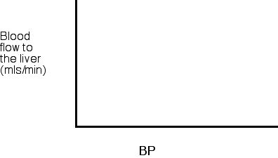
Now list four different factors or mechanisms that may be responsible for this phenomenon:

1.________________________________________________________

2. ________________________________________________________

3. ________________________________________________________

4. ________________________________________________________
#8. If the radius of one small artery doubles, the blood flow through that artery will increase by a factor of:
Put a number here → ___________
#9. Briefly explain the one main cardiovascular advantage and the resulting beneficial consequences realized by a highly conditioned athlete that allows prolonged bouts of exercise:
_________________________________________________________________

_________________________________________________________________

_________________________________________________________________
#10. Finally, let’s earn easy points by answering 20 Up- Downs with I, D, or NoΔ:
a. As EDV increases, PP
a. ________
b. As a subject’s lungs inflate, afferent vagal
nerve activity b. ________
c. As blood leaves the capillaries, the velocity
of blood flow c. ________
d. As blood leaves the capillaries, blood pressure
d. ________
e. As TPR increases, SP
e. ________
f. As plasma epinephrine increases, SA node
Na⁺ conductance f. ________
g. As arterial compliance decreases, DP
g. ________
h. As atrial EDV increases, the rate of urine output
h. ________
i. As atrial EDV increases, renal Na⁺ excretion
in the urine i. ________
j. As plasma renin increases, reanl Na⁺ reabsorption
j. ________
k. As blood volume increases, plasma ADH
k. ________
l. As blood volume decreases, plasma ANP
l. ________
m. As plasma propranolol increases, the length
of the ECG P wave to P wave interval m. ________
n. During stimulation of the efferent vagal nerve, SA node
K⁺ conductance n. ________
o. As EDV decreases, VR
o. ________
p. As plasma ADH levels increase, blood volume
p. ________
q. As atrial EDV decreases, plasma aldosterone
q. ________
r. As TPR increases in a healthy individual,
CO r. ________
s. As ventricular EDV increases, the number of cross bridges
formed in each ventricular muscle cell s. ________
t. As plasma CO₂ increases, medullary CSF pH
t. ________

