BSCI 440; Spring, 2003 TA:__________________
W.J. Higgins The Finale

DIRECTIONS:
1. PRINT your name on each page of the examination NOW.
2. Tear off the last page of the examination. It contains the data you will need to answer several questions. Use it for scratch paper. It will NOT be collected.
3. You absolutely, positively MUST confine your answers to the spaces provided. Failure to do so may result in an inaccurate evaluation of your knowledge.
4. You may use a pencil if you wish; there are no re-grades of the Final Exam.

Question | Higgins Points | Visitor’s  Points | Question | Higgins Points | Visitor’s Points
1 | 20 |  | 5 | 25
2 | 32 |  | 6 | 30
3 | 48 |  | 7 | 55
4 | 20 |  | 8 | 20
 |  |  | TOTAL | 250

#1. Use the data on the last page:

a. Give an approximation of V_{m}: ____- 61.5 mV_____________mV

b. What is ER-? ______- 68.88 mV_____________mV
c. From looking at the data table, what can you infer about the real value of Vm?

_______________It is more positive than the approximation_____________
d. Under the above conditions and at the V_{m} predicted in part a, is there a net movement of R- across the membrane? If so, which way does it move?

It moves in________
e. Now calculate the true, accurate value of V_{m}
______-50.4_____mV
f. What value can Vm reach during an action potential?
____+ 65.6____mV
g. List two changes in extracellular ion concentrations from the table that would result in hyperpolarization:

decrease [L+] or [D+] or increase [R-]

h. List two changes in ion permeabilities that will result in depolarization:

increase P of D+ or F++ or decreases P of L+ or R-

#2. For each of the following responses, indicate the branch of the nervous system (Parasympathetic, Sympathetic, or Somatic), the neurotransmitter(s) released onto the effector organ/cell, the receptor acted upon, and whether this is an excitatory (E) or inhibitory response (I): (do not include ganglionic sites)

Response System NT Receptor E or I

Decreased BF to gut ___Sym_____ ___NE_____ ____a1____ ___E_____

Increased BF to skeletal muscle ___Sym____ ACh & Epi_ ___M & b2_ ___I____

Increased HR ___Sym___ ___NE_____ ____b1____ ___E_____

Dilation of pupil __Sym____ ___NE___ ___b1_____ ___E_____

Contraction of diaphragm __Som_____ ___ACh____ ___N______ ____E_____

Increased sweat production __Sym & P_____ __ ACh_ ___M___ ___E____

Constriction of bronchiole ___Para___ __ACh____ ___M____ ___E_____

Decreased intestinal contractions __Sym____ __NE/Epi____ ___a2 & b2__ ___I_____

#3. Predict the actions of each of the following agents using up or I for increase or D for decrease and "NC" for no change.
Agent HR SV TPR CO DP PP

ACh _D__ __I__ __D_ _D__ _D__ __I__
Atropine +
ACh (high dose!) _I__ _I__ _I___ __I__ _I___ __I__
Epi _I___ _I___ __I__ __I__ __I__ __I__
Beta antag. + Epi __NC _I__ __I_ _I _ __I__ __?__
Alpha antag. + Epi __I__ _I___ __D__ _I___ _I___ _I___
Digitalis _D__ __I__ __NC__ __D__ __D_ __I__
Histamine _NC__ _D___ __D__ __D__ __D__ __D__
Propranolol __D__ __I__ ___NC/I_ __NC/I__ __D__ __I__
#4. Using the data from the last page, answer each of the following:

a. Renal Blood Flow _____201.4 ml / min_____
b. GFR ______25 ml / min________
c. Individual’s Plasma Volume ___2 l or 2000 ml__
d. Cardiac Output ______4.48 l/min_____
e. MAP ____90 mm Hg___
f. Rate at which P appears in urine ______0.025 mg/min____
g. Rate at which X is filtered _____0.175 mg/min______
h. Rate at which Z appears in urine ________0_________
i. Filtration Fraction _______0.22__________
j. Individual’s Interstitial Volume __3 l or_3000 ml_______

#5. Examine the plasma data on the last page and categorize this person’s condition:

_________metabolic acidosis___________

What is the initial homeostatic mechanism that will attempt to correct this situation? Explain how it does this.

_____increased respiration, decreases plasma CO₂ (and H+ and bicarb), and____

____________this increases plasma pH____________________

What mechanism will eventually bring the situation completely back to normal? Explain how it does this.

_Eventually the kidney will increase renal H+ secretion and HCO3- reabsorption

________________________________________________________________

Graph the condition and the two (short & long term) corrective mechanisms. Label both axes and your plots:
7.4
Plasma pH
Plasma
HCO₃⁻
1
2
#6.
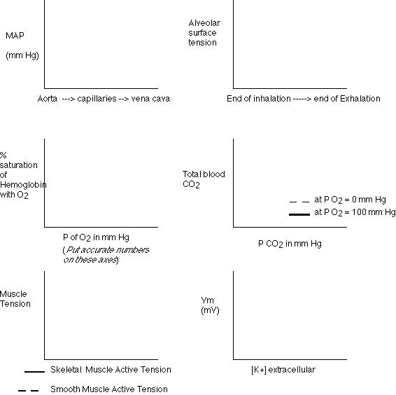
Fig 16.8

#7. Why not a few increase (I) - decrease (D) - no change (NC) questions?

a. As the stimulus intensity is increased, the amplitude of the resulting
graded potential a_____I_____
b. As the stimulus intensity is decreased, the distance traveled by a
graded potential along a cell membrane b____D_____
c. As the radius of an unmyelinated axon increases, conduction
velocity c___I______
d. As the dose of hexamethonium is increased, the response
of the isolated ileum to a subsequent fixed dose of ACh d___NC_____
e. As venous blood pressure is increased, capillary reabsorption
e____D____
f. As the plasma osmotic pressure increases due to higher [protein]
interstitial fluid volume f____D____
g. As nicotine is administered to your lab partner, his/her pupil
diameter will first g___D____
h. As the partial pressure of O2 in the atmosphere decreases, the P50
of hemoglobin h___NC_____
i. As the pH of the plasma increases, the P50 of hemoglobin
i___D____
j. As the capillary plasma [histamine] increases, capillary filtration
j____I____
k. As the caudal end of a cut vagus is stimulated, HR
k___D______
l. As the cephalic end of a cut vagus is stimulated, TPR will
l___I_____
m. As an intact right vagus is stimulated, alveolar ventilation
m___D_____
n. As BP decreases, pressor area activity
n____I____
o. As plasma NE levels increases, VR
o___I______
p. As EDV increases, cardiac contractility
p___I______
q. As plasma CO2 levels rise, VR will soon
q___I______
r. During the P wave of the ECG, ventricular volume
r___I_____
s. As arterial compliance decreases, diastolic BP
s___I______
t. As ventricular cyclic AMP levels increase, cardiac contractility
t__I_____
u. As levels of active factor X increases, plasma levels of thrombin
u____I_____
v. As stroke volume decreases, VR
v____D_____
w. As venous pressure increases, VR
w___D______
x. As duodenal pH decreases, plasma [secretin]
x___I______
y. As plasma atrial natriuretic hormone levels increase, renal
sodium reabsorption y___D______
z. As hyperthermia progresses, hemoglobin P50
z___I______
aa. As alveolar radius increases, the total alveolar wall tension
aa____I____
ab. In the lung, plasma [HCO3-]
ab___D_____
ac. As a base is added to the blood, plasma [CO2]
ac__D_______
ad. As plasma [secretin] increases, gastric motility
ad____D_____
ae. As efferent arteriole diameter decreases, GFR
ae___I______
af. As DCT sodium levels decrease, systemic BP will soon
af____I_____
ag. As blood flows through the peritubular capillaries, plasma
[inulin] ag____D_____
ah. As plasma osmotic pressure decreases, CD water permeability
ah____D_____
ai. As the extraction ratio of a substance increases, the clearance
of that substance ai__I_______
aj. As plasma ADH levels increase, the osmotic pressure of
the plasma aj___D_______
ak. As tubular fluid flows through the DCT, tubular fluid [K+]
ak___I______
al. As inhalation proceeds, afferent vagal nerve activity
al___I______
am. As plasma aldosterone levels increases, tubular potassium
secretion am___I______
an. As the partial pressure of nitrogen is increased, the rate of
O2 diffusion into the blood an___NC_____
ao. As the plasma [PAH] increase above the Tmax, PAH
excretion ao___I_____
ap. As plasma [glucose] increase above 200 mg/100 mls, renal glucose
filtration ap___I______
aq. Under normal physiological conditions, as BP decreases, GFR
aq___NC______
ar. As saliva flows down the salivary duct, saliva [HCO3-]
ar___I_____
as. As plasma pH decreases, tubular reabsorption of HCO3-
as__I______
at. As chyme protein content increases, plasma [secretin]
at____I_____
au. As gastric [peptides] increase, gastric pH
au____D_____
av. As chyme fat content increases, plasma [cholecystokinin]
av __I_______
aw. As respiratory alkalosis occurs, plasma [HCO3-]
aw____I_____
ax. As tunular fluid flows through the PCT, tubular [inulin]
ax____I____
ay. As gastric distention increases, afferent vagal nerve activity
ay____I_____
az. As gastric distention increases, activity of the efferent vagal
nerve to the stomach az____I_____
ba. As duodenal peptide content increases, plasma [gastrin]
ba___D_____
bb. As plasma CCK levels increase, the rate of gastric emptying
bb____D_____
bc. As a student’s testosterone levels increase, his IQ bc___D______

#8. Carbonic Anhydrase:

At the least I expected consequences of inadequate regulation of body fluid pH, problems with respiration (including decreased O2 and CO2 unloading), problems with digestion including decreased stomach acid leading to lack of pepsin activation and diminished protein digestion (see acid chyme’s role in CCK and secretin release), and inability of renal system to regulate plasma pH. Some of you got into the spirit of the thing and found osteopetrosis, cerebral calcification, CSF production problems, and renal disorders.

Thank you all again for taking 440 this past spring. I had a great time and enjoyed a wonderful semester. Do something amazingly and awesomely cool this summer, something you would not ordinarily consider doing. Soon the pressures and obligations of life will catch up to you and, unless you are a professor at a university, make you old and (worse) conservative.

Affectionately, Dr. Know-It-All

